Assignment 1: Data Visualisation

Abdulaziz Mohamed Nur

GLA 1 2022

Task 1: Policies and Procedures 3

Task 2: Excel 4

Task 3: Tableau 11

# Task 1: Policies and Procedures

There are various policies and procedures that must be adhered to when working with data.

The one that is relevant when using Data sets such as these is the Data Protection Act (2018) (including the UK GDPR)

**Data Protection Act (2018):**

The Data Protection Act (2018) sets out the guidelines for data protection law in the UK. It updates and replaces the Data Protection Act 1998, and came into effect on 25 May 2018. It was amended on 01 January 2021 by regulations under the European Union (Withdrawal) Act 2018, to reflect the UK’s status outside the EU. Essentially, The Data Protection Act 2018 controls how your personal information is used by organisations, businesses or the government.

The Data Protection Act (2018) states that any organisation must make sure that personal data is:

* used fairly, lawfully and transparently
* used for specified, explicit purposes
* only used where necessary
* accurate and kept up to date
* kept for no longer than is necessary
* handled in a secure way, including protection against unlawful or unauthorised processing, access, loss or damage

It is important that these are adhered to as not doing so is a breach of the law and comes with consequences. The DPA 2018 set a maximum fine of £17.5 million or 4% of annual global turnover – whichever is greater – for infringements.

As a Data Analyst, you must be aware of the Data Protection Act (2018) as it directly affects your work. An example of this

# Task 2: Excel

I will be using the online version of Excel for this.

1)

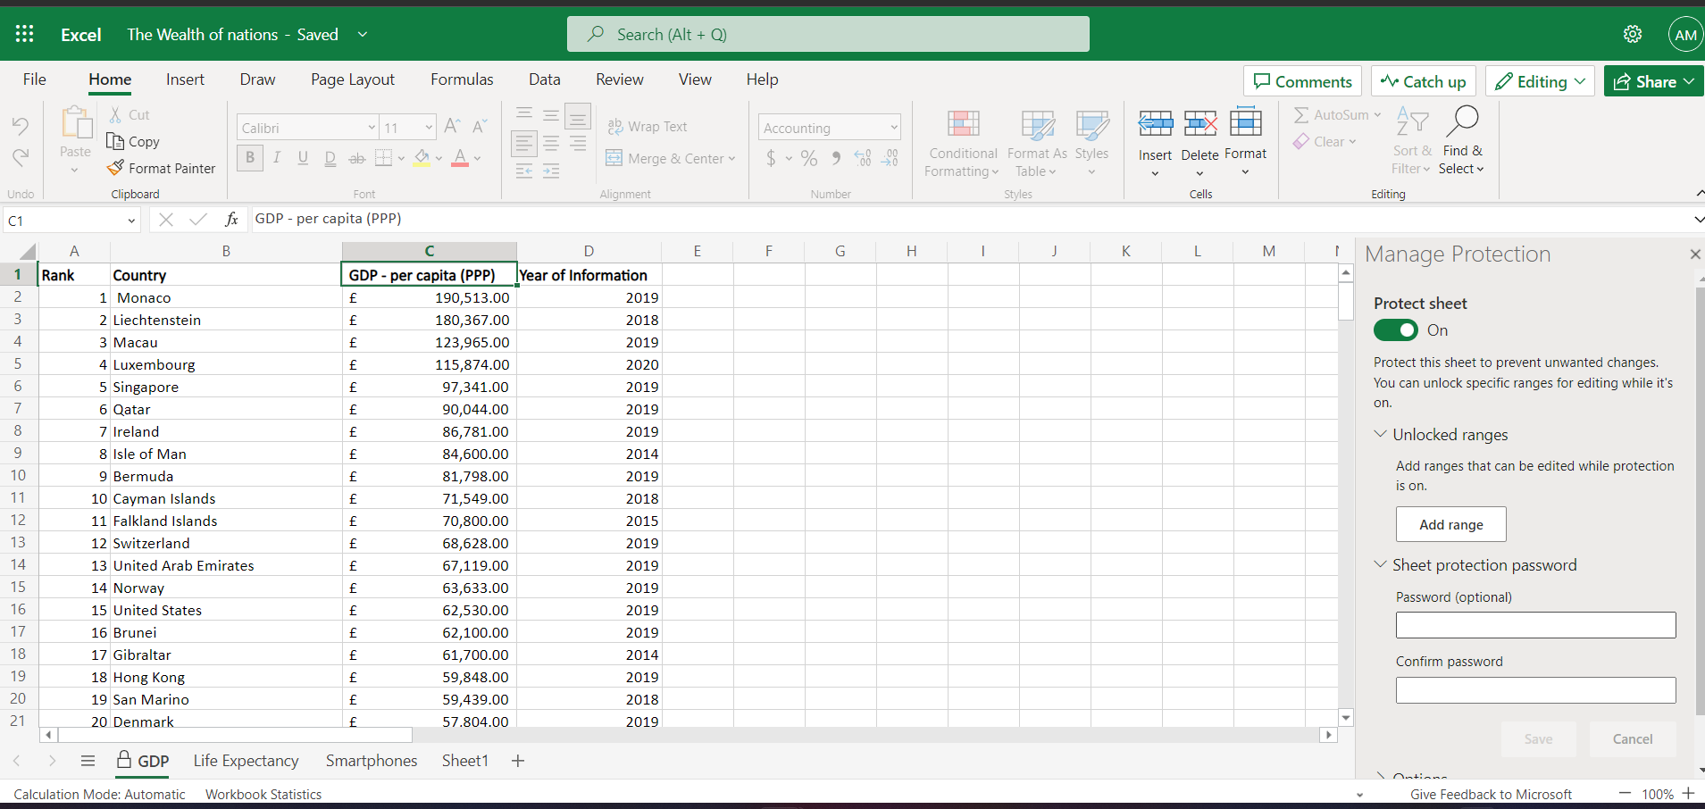

Here you can see me setting a password for this sheet by right clicking the tab titled “GDP” at the bottom and selecting “Manage Protection”. I then set “Protect Sheet” to the on setting and then put in the desired password below.

2)

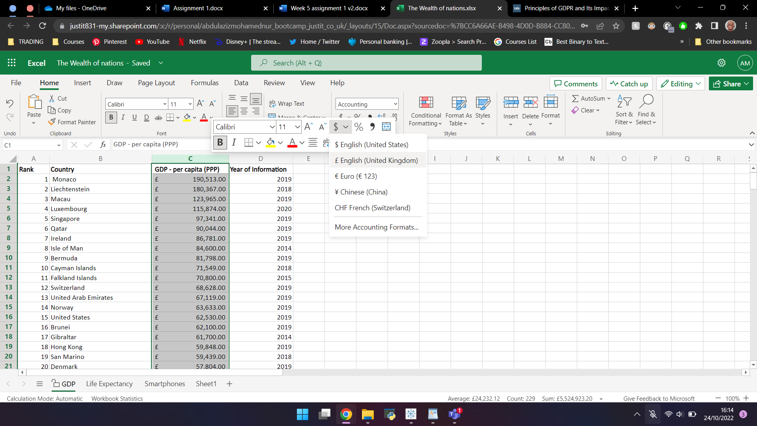

I have highlighted the C column and right clicked in order to change the data to display the British Pound Sign (£). There are various methods to do this but this is the one I have chosen for this instance.

3)

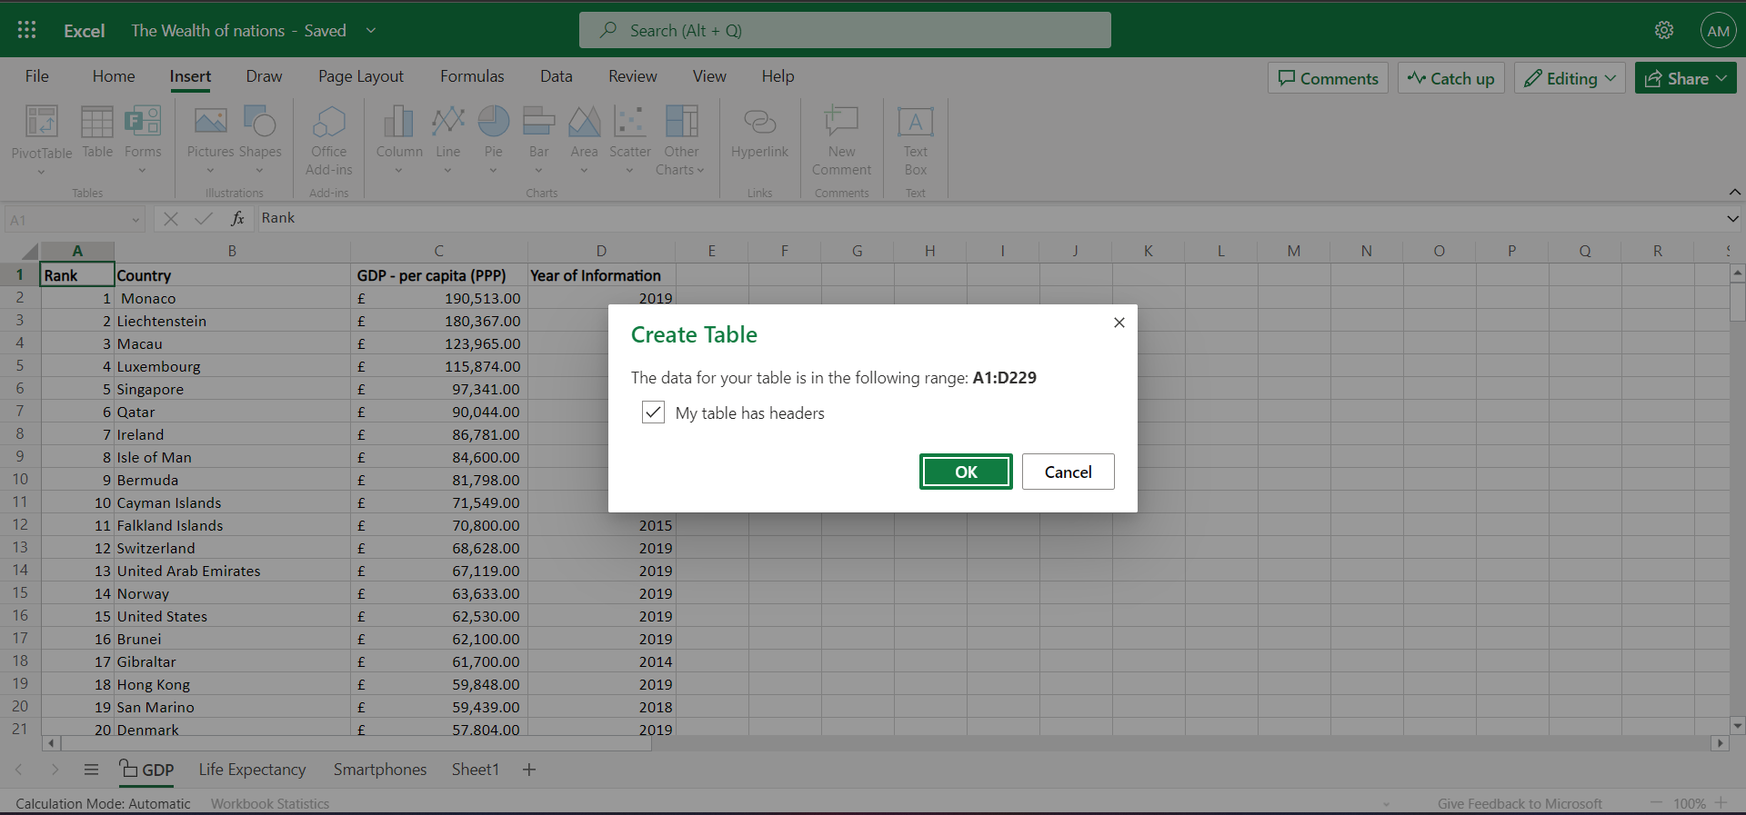

By selecting a cell which contains data and then selecting “Table” in the “Insert” tab at the top, I have created a table. Above you can see the prompt to create a table and below you can see the created table.

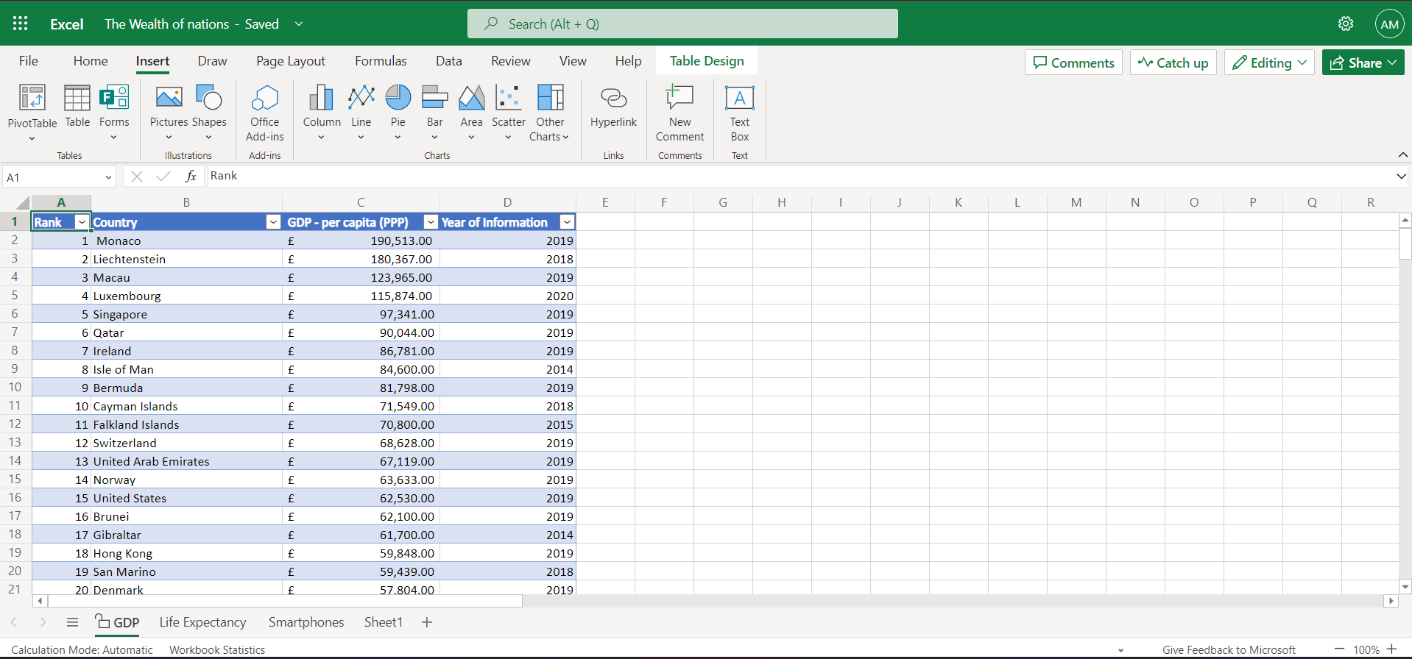

4)

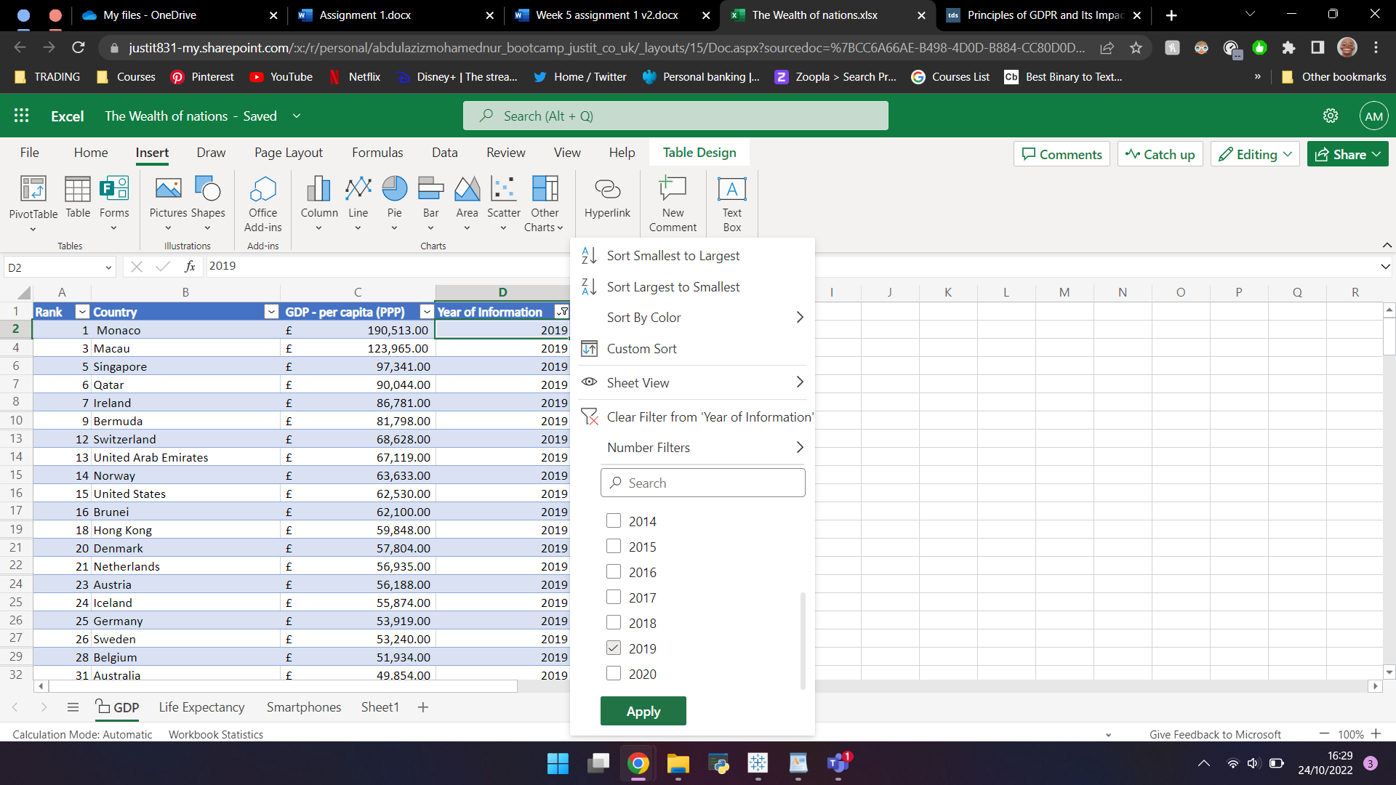

Here I have right clicked the column containing the year in order to filter the data to only the 2019 data

5)

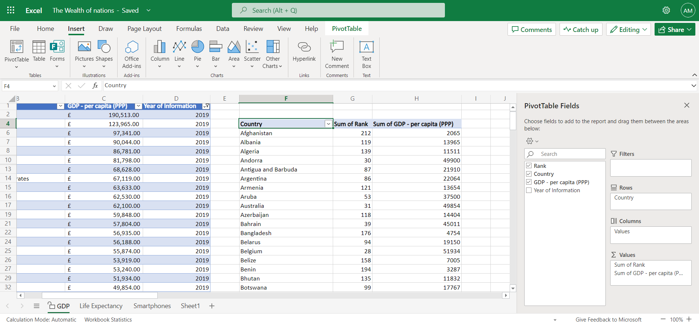

I created a Pivot Table only showing the Rank, Country and GPD – Per Capita (PPP) values.

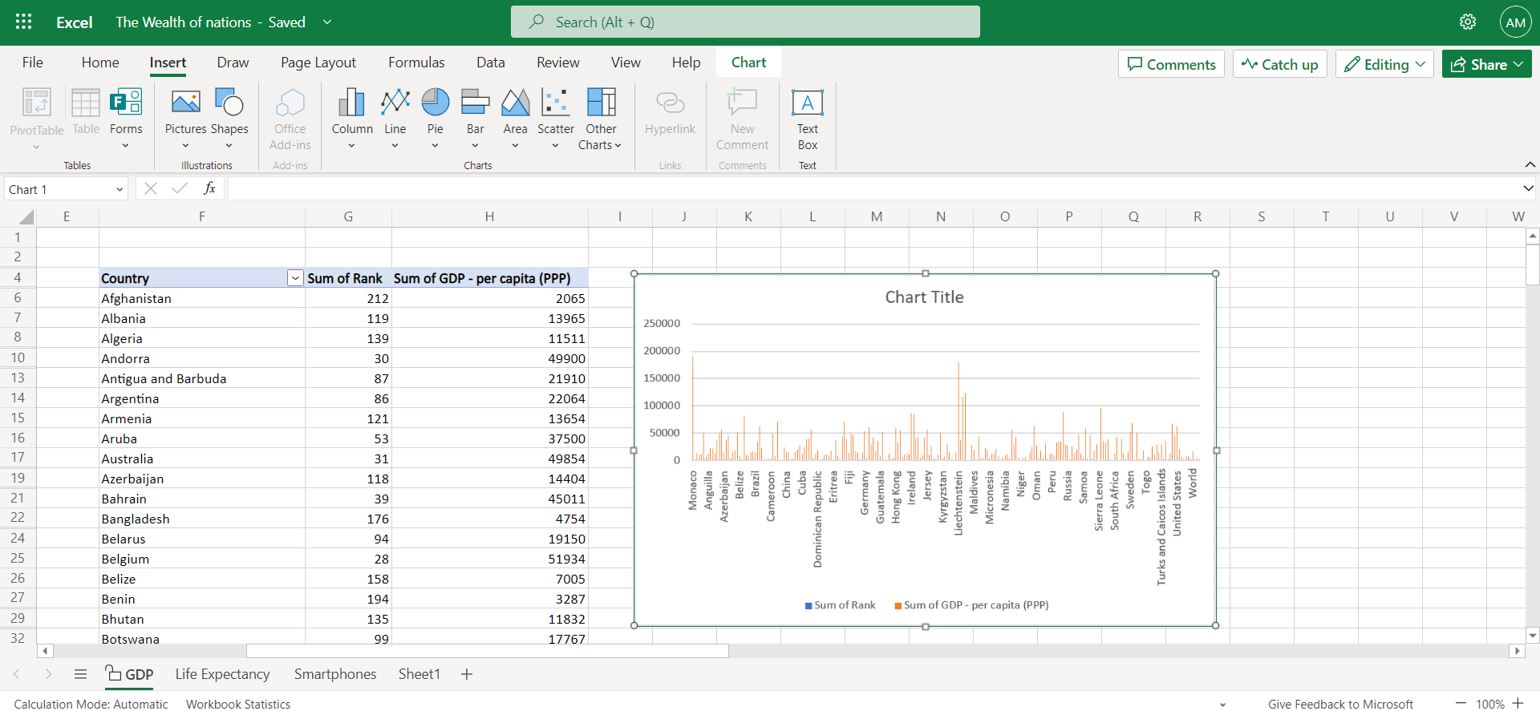

I then selected the Pivot Table and inserted a graph by selecting a cell within the Pivot Table then clicking on “Column” under the “Insert” tab.

6)

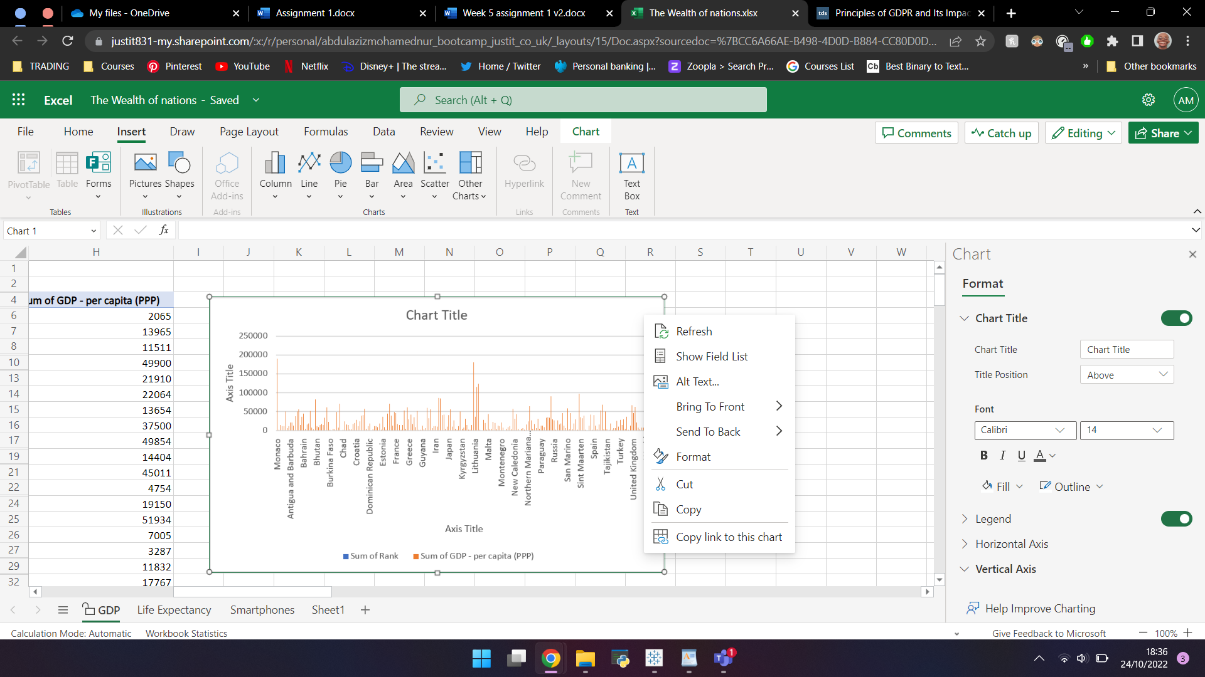

By right clicking the chart and selecting “Format”, I am able to add a title, labels for the axis as well as edit the charts visuals.

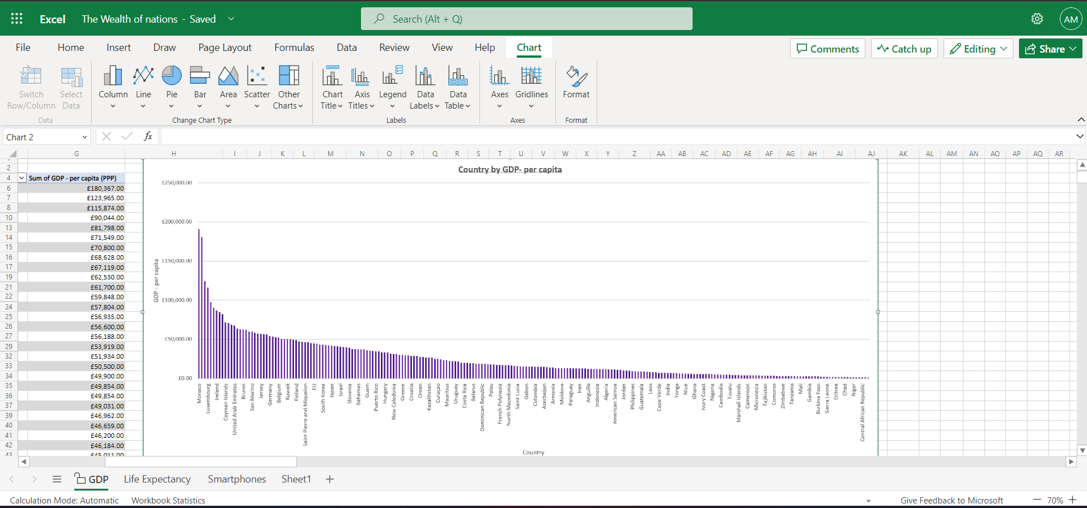

I ordered the chart by rank, changed the colour of the bars, added axis labels and a title. I decided to keep the white background as it allows you to see the bars and values better.

7)

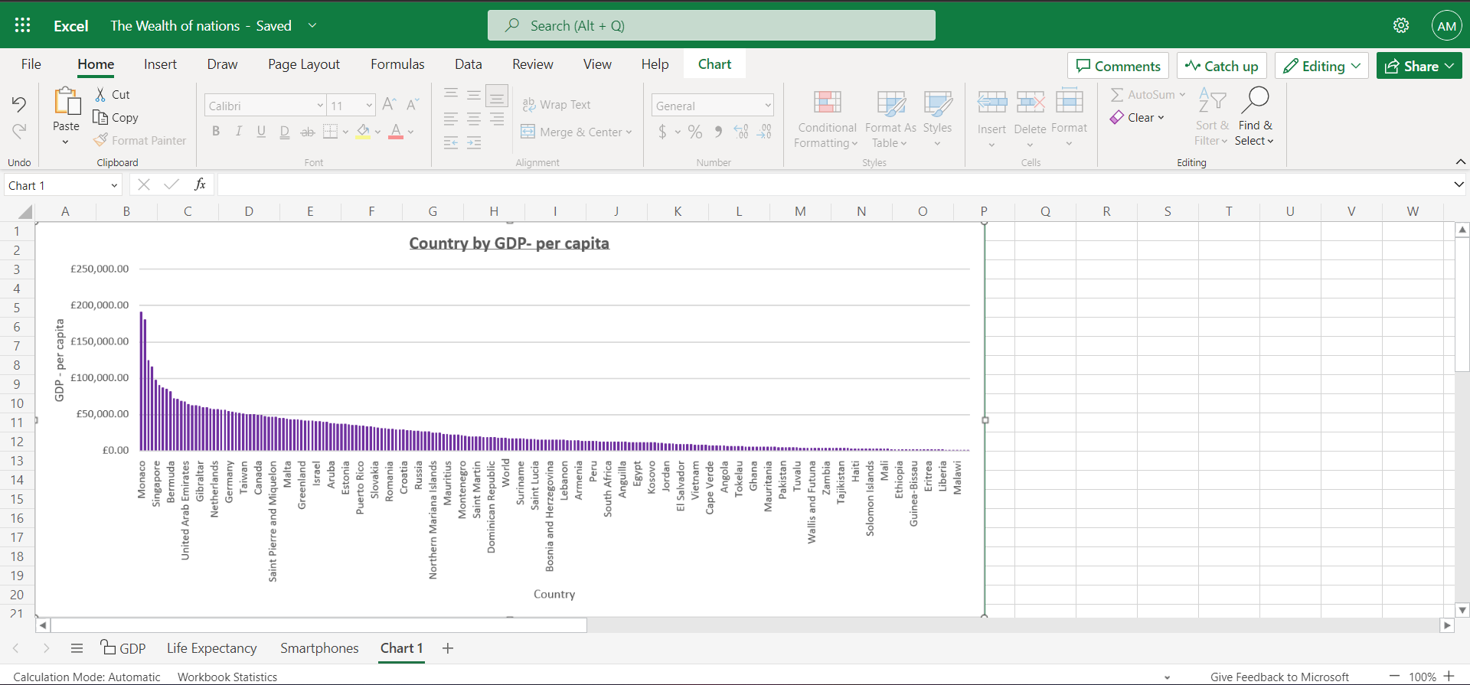

I moved the chart to a new sheet that I renamed “Chart 1”.

8) + 9)

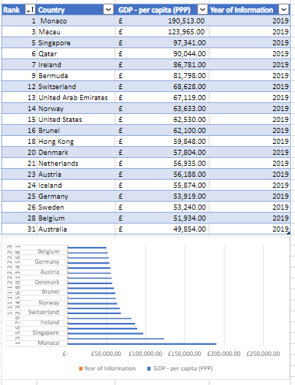

Here are the top 20 sorted with a bar chart to show this further

10)

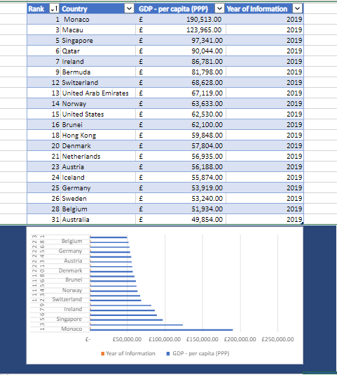

I’ve highlighted the area under the graph and used the bucket icon to add a background colour.

11)

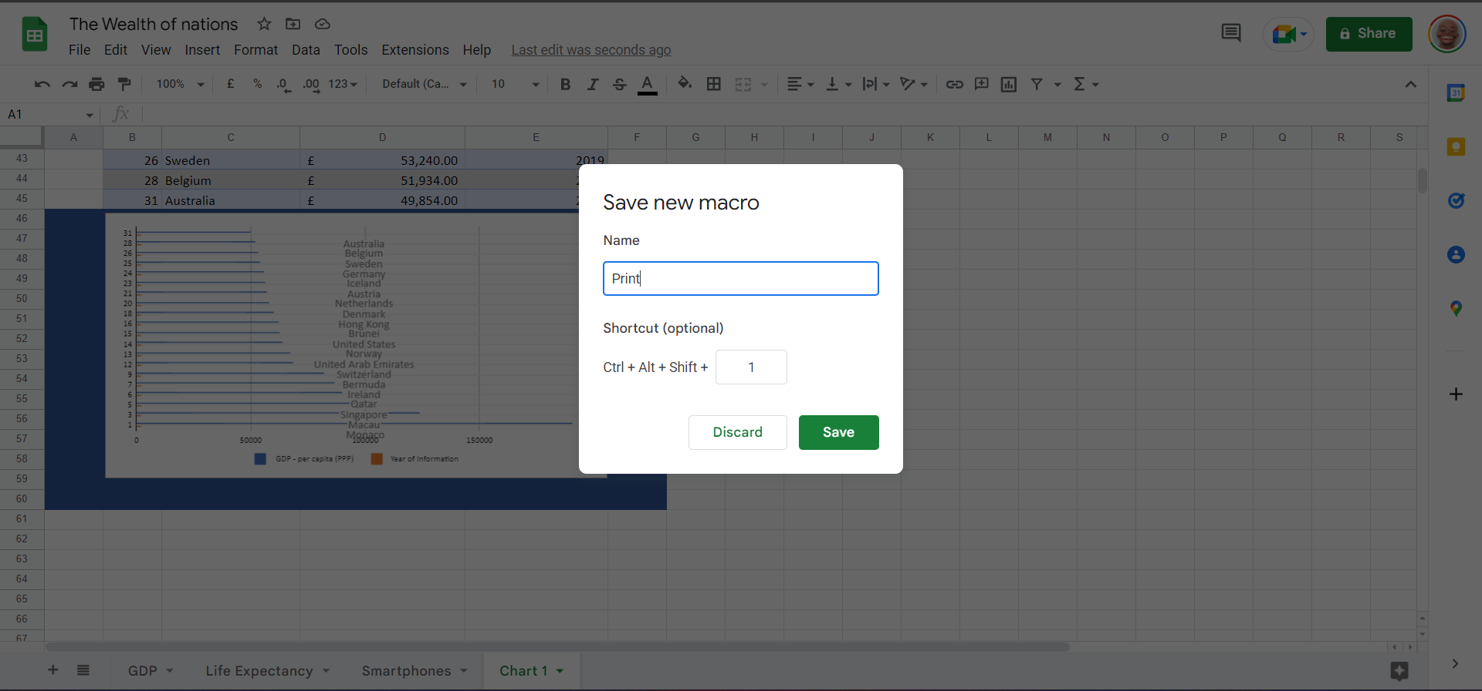

Due to the limitations of Excel’s online version, I moved over to google sheets. Here I selected “Record Macro” from the “Extension” tab. I then recorded print and saved the macro, saving it as Print. I did the same for Copy and Save.

I then created buttons using the “insert shape” function and assigned each their respective macros using the “assign script” function available after selecting the 3 dots next to each button:

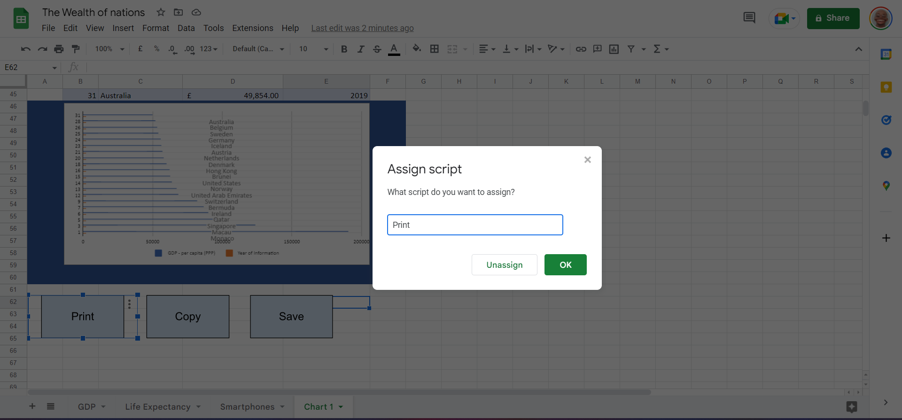

# Task 3: Tableau

1)

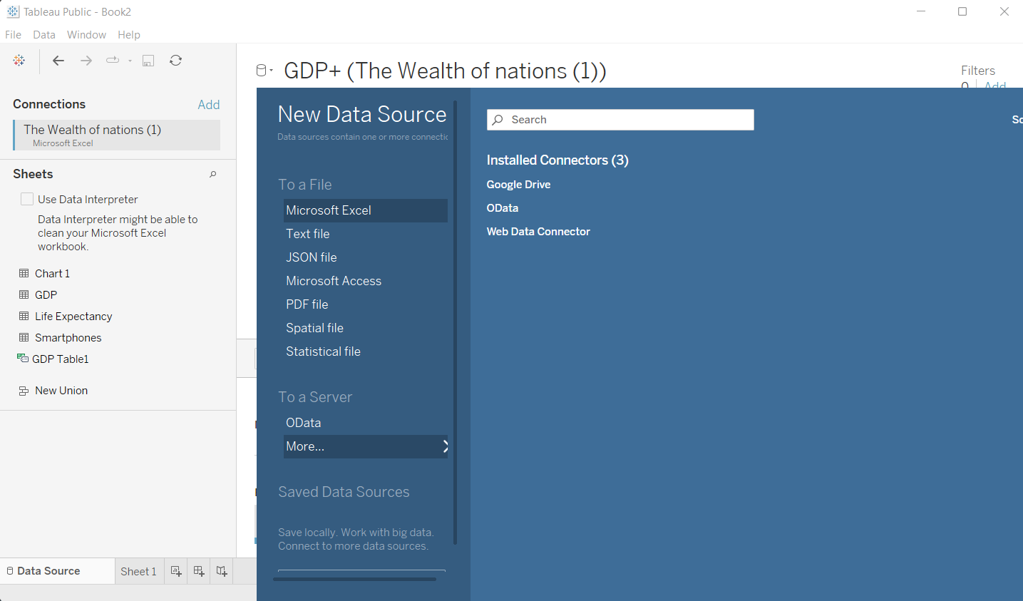

I imported the data from the Wealth of Nations excel workbook.

2)

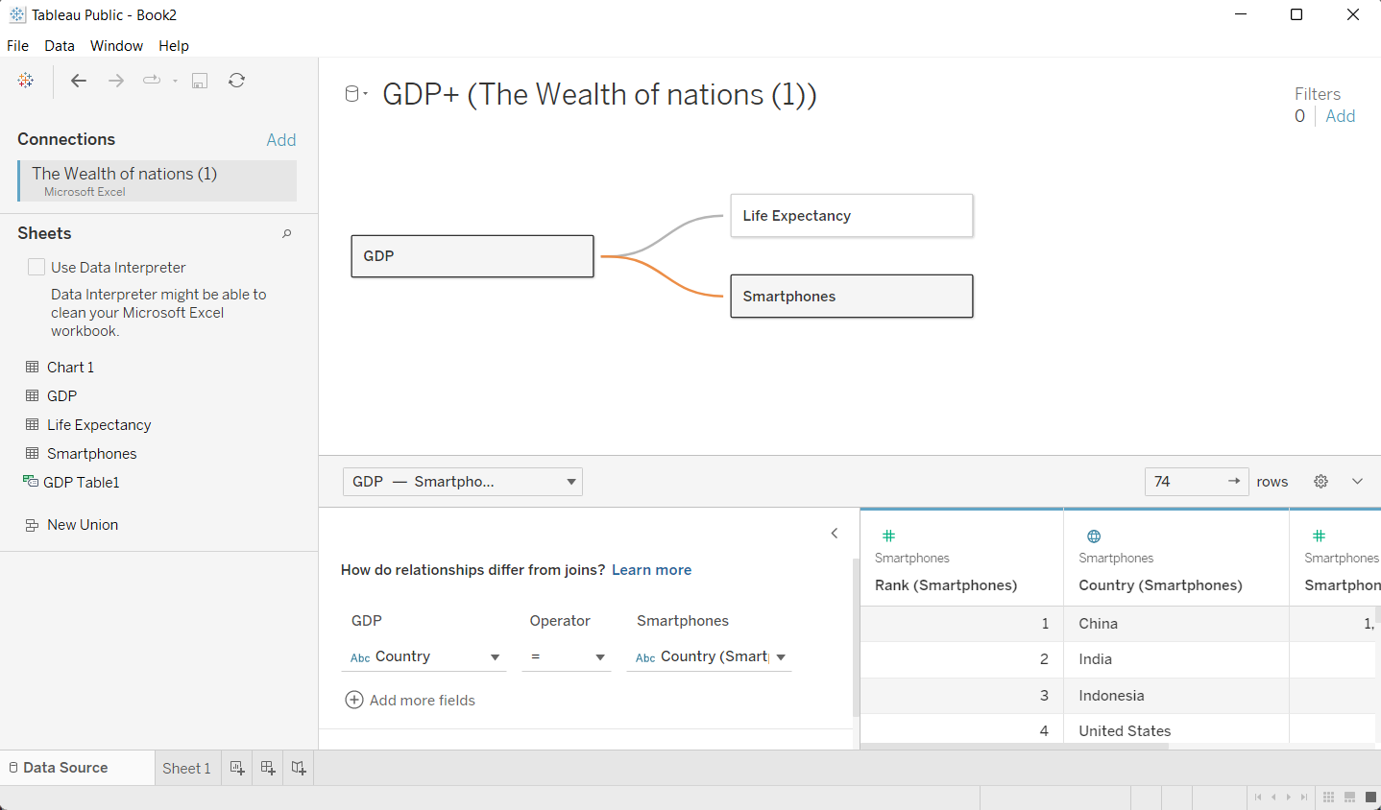

I then set the relationship of the data. The common column is Country.

3)

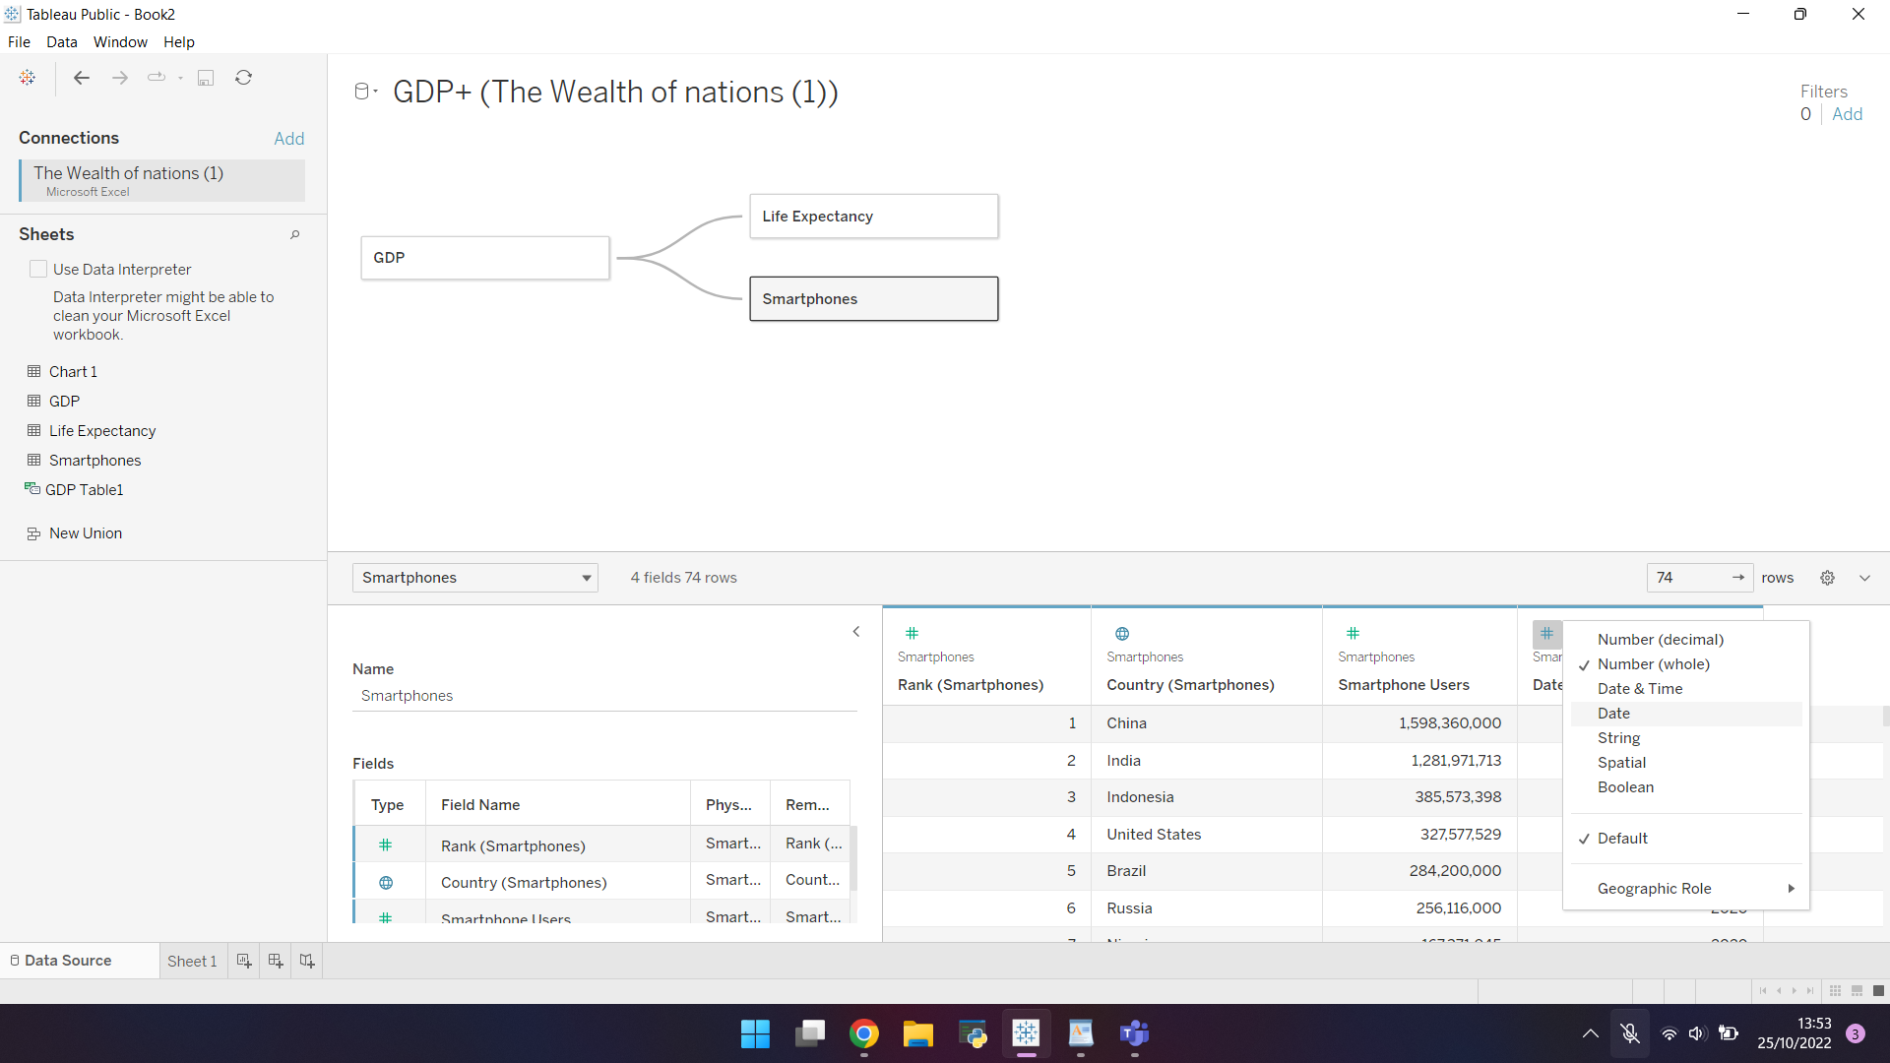

I then check and correct the data types.

4)

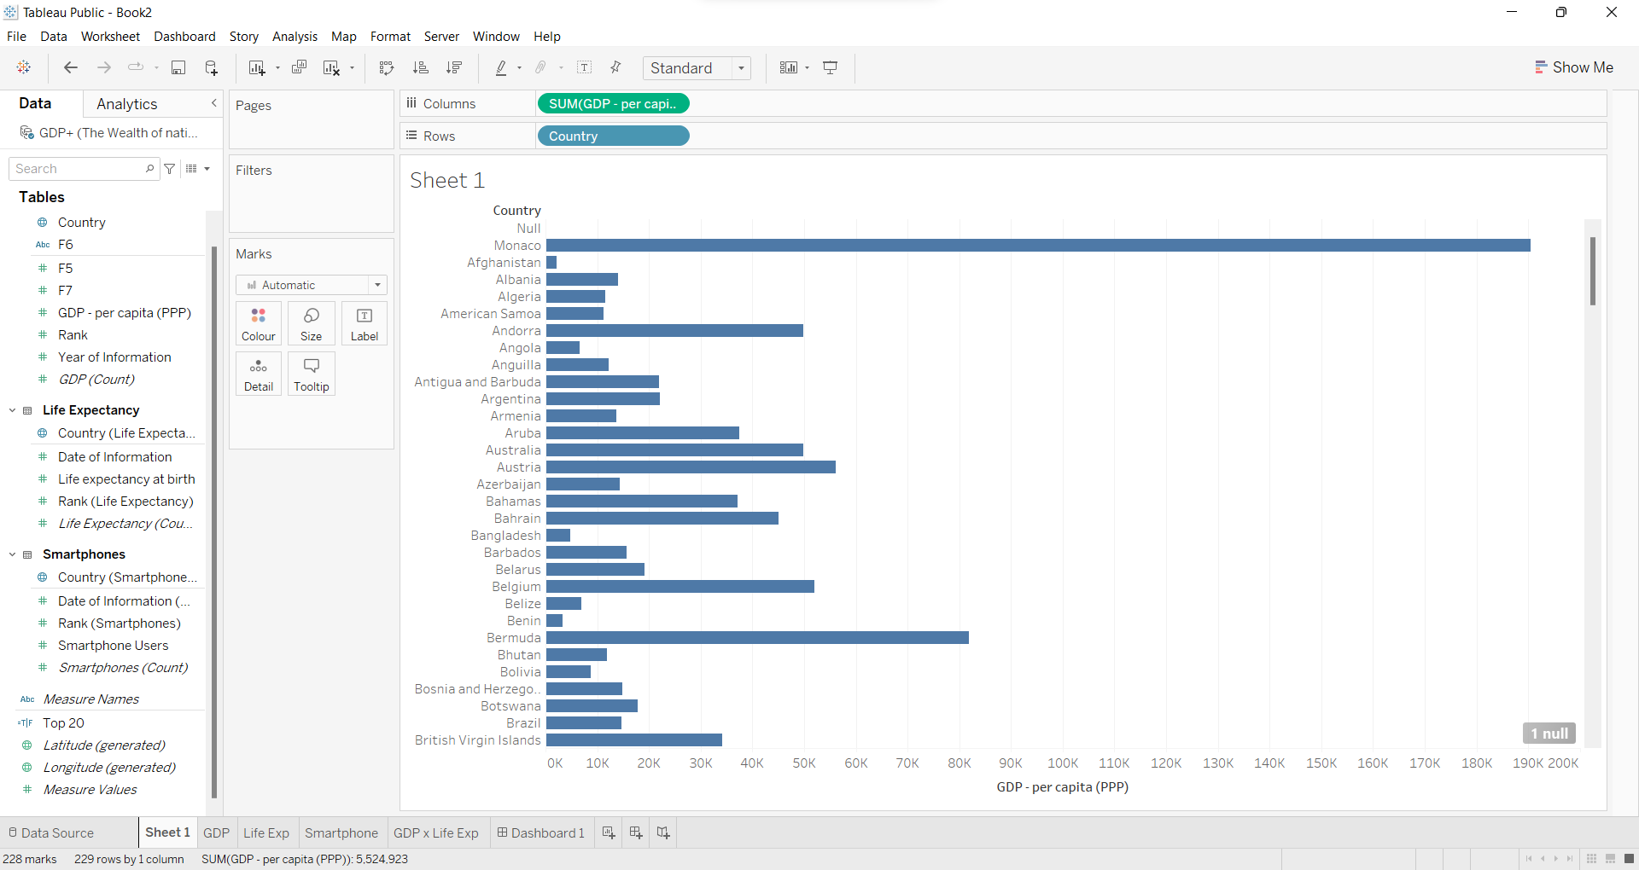

After opening the sheet here titled “Sheet 1”, I drag and drop the variables for the graph I want to create into the “Rows” and “Columns” shelfs at the top of the page. This creates a graph as can be seen above.

5)

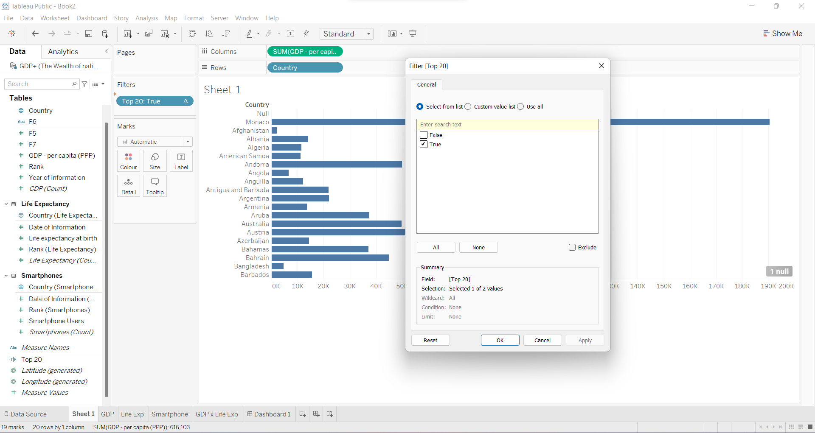

Since the client is only interested in the top 20, I created a calculated field using the formula INDEX()<=20 which only showed the top results. I then drag and dropped the formula into the “Filters” shelf and set it to “True” as seen above. I then sorted in descending order to only show the top 20.

Since the client is colourblind I selected the “colourblind” colour palette which consists of mainly blue and orange. Using this palette and keeping in mind that the client is only intested in the top 20, I created a few more charts and a map as seen below:

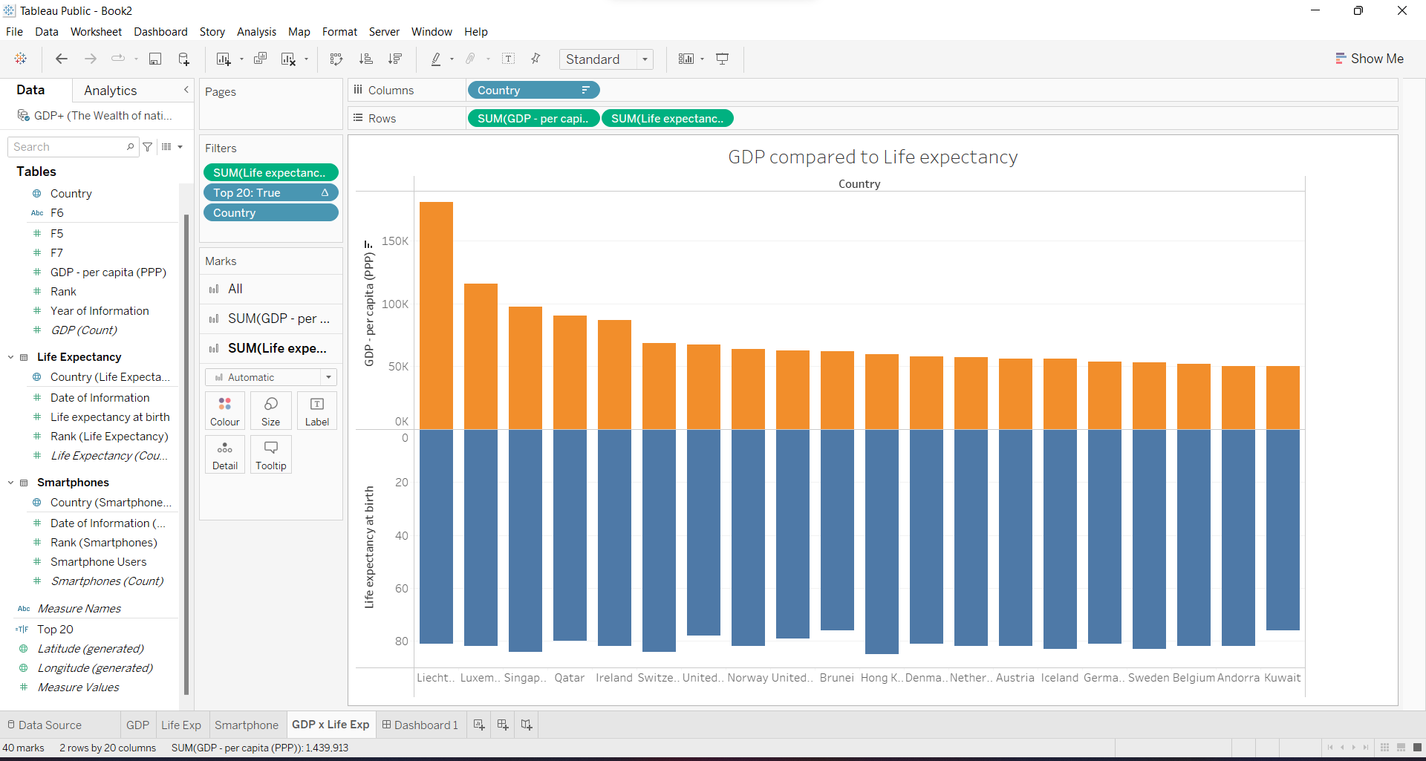

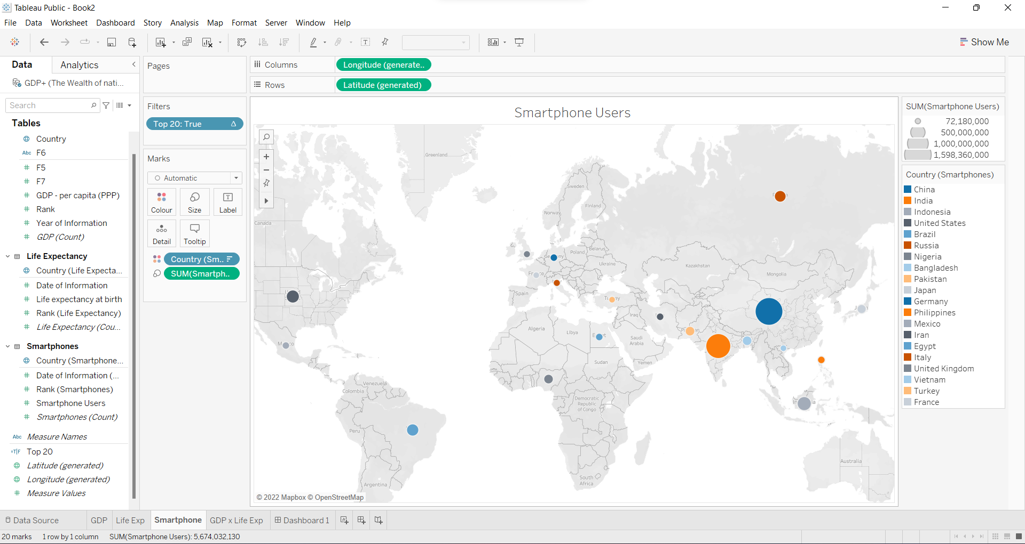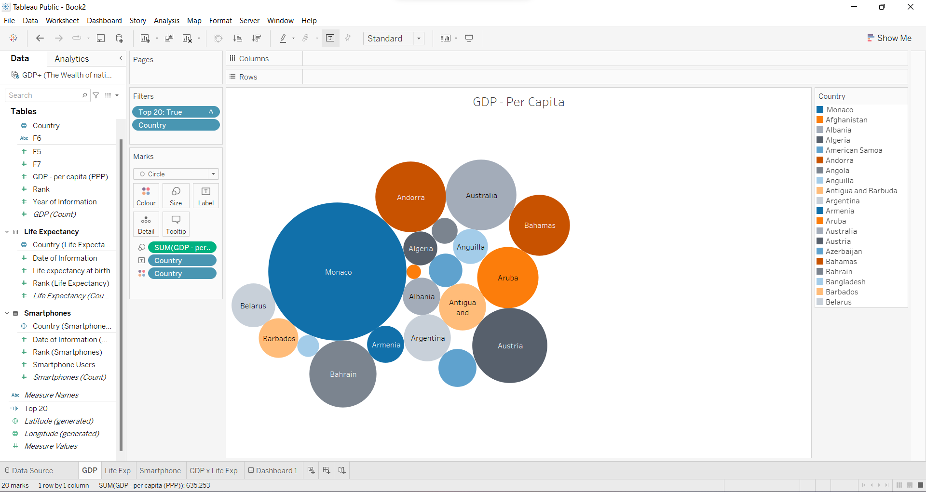

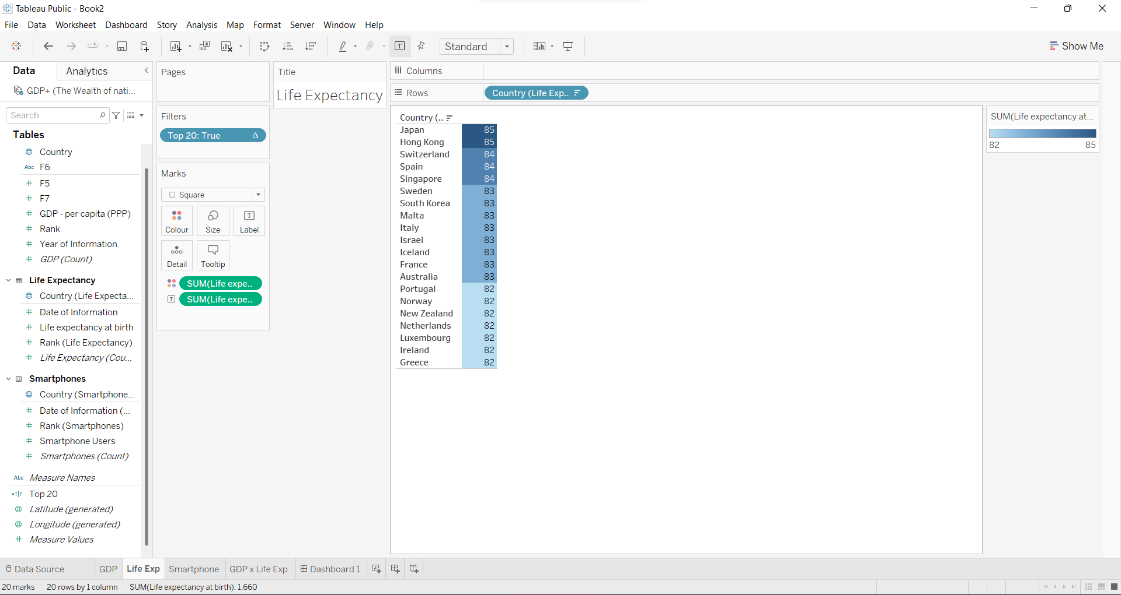

I then combined these graphs and charts onto a single dashboard with an interactive map as seen below:

